Title:
The First Land of the Avesta: Arəzahī, the Origin of Mithra, and the Sacred Geography of Āzrah-jat (1500–1200 BCE)

Description / Abstract:
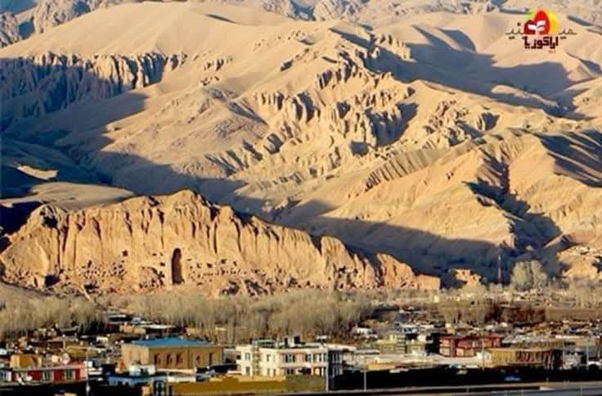
Where did the Avesta — the sacred text of Zoroastrianism and one of humanity's oldest religious traditions — first emerge? And where did the ancient god Mithra (Miθra), the deity of light and covenant, originate?

The oldest Avestan texts, dating to 1500–1200 BCE (before the Christian era), name Arəzahī as the easternmost clime (karshvar) — "the place where the sun rises for the first time" (Mihr Yašt 10.15). This land is the heart of Airyanem Vaejah (Vendidad 1.2), the original homeland of the Aryans. The same eastern Iranian world is also the birthplace of Mithra, the ancient Indo-Iranian god of light and covenant, who appears in both the Avesta and the Vedic texts.

Leading Iranologists — Michael Witzel (Harvard University) and Gherardo Gnoli (Sapienza University of Rome) — identify this sacred geography with the central highlands of Afghanistan, between the Helmand River (Haētumant) and the Hindu Kush mountains.

Today, this land is called Āzrah-jat (Hazarajat). Its people still call themselves Āzrah — a name that is the direct linguistic continuation of Avestan Arəzahī. Their native dialect, Hazaragi (Āzragī) , preserves 25–35% of its core vocabulary directly from Avestan — including words like Āv (water), Zīmī (earth), Gīrū (mountain), Kata (house), and Āsmo (sky). These are not loanwords; they are living linguistic fossils.

The sacred mountain Harā Bərəzaitī (the world-axis of Avestan cosmology) is the Koh-i Baba range in the heart of Āzrah-jat. The Helmand River still flows from its source here. And Mithra, the ancient deity of light and protector of truth (Asha), first rose from these mountains long before his cult spread westward to Rome.

This is not mythology. This is a scientific identification based on three independent lines of evidence:

1. Linguistics: Avestan place names and vocabulary preserved in the living Hazaragi dialect (25–35% retention).
2. Genetics: The Āzrah people possess the highest frequency of the Neolithic Iranian haplogroup J2a1-Page55 (13%) and G2 (8.7%) in Afghanistan, demonstrating direct biological continuity with the ancient farmers of the Iranian plateau (PLOS ONE, 2013).
3. Geography: Direct topographical correlation between Avestan texts and real-world locations in central Afghanistan, confirmed by independent scholars from Harvard, Rome, and Leipzig.

Read the full paper to see the evidence. The first light of the Avesta — and the first light of Mithra — still shines from Āzrah-jat.

---

Keywords (for tagging):
Avesta, Arəzahī, Airyanem Vaejah, Āzrah, Hazaragi, Mithra, Miθra, Harā Bərəzaitī, Helmand River, Haētumant, Zoroastrianism, sacred geography, ancient Iran, Ariana, central Afghanistan, Hazarajat, 1500 BCE, 1200 BCE, Michael Witzel, Gherardo Gnoli, haplogroup J2a1, PLOS ONE

---

